**JSU Nursing 50th Anniversary Microsite**

History:

The Lurleen B. Wallace School of Nursing was created by the Legislature of the State of Alabama in 1967 to award the Bachelor of Science (BS) degree with a major in nursing. At the time of the creation of the School of Nursing, only two other baccalaureate programs existed in the state. The first graduating class of ten completed the program in 1972. To date, over 3,200 students have graduated from the traditional nursing program.

In the first 25 years of existence, the College of Nursing and Health Sciences (CNHS) offered only the traditional BSN program.  Until the 1980’s, nurses with associate degrees or diploma degrees in nursing were limited to traditional programs to complete the baccalaureate degree.  Given the demands of traditional programs, those wishing to pursue a BSN typically could not remain employed, thus the number of RN to BSN students was abysmal.   CNHS Dean Roberta Watts recognized the need to use alternate means of delivery so that practicing RNs would have viable options for completing the BSN.  In the mid-1990s she spearheaded an innovative approach to RN to BSN education.  The CNHS launched a “distance education” RN to BSN program, the Strategic Teaching for Enhanced Professional Preparation or STEP Program.  In its initial design, RNs came to campus a minimal number of days (typically three days per semester) and were provided lectures on videotapes.  Facilitating the attainment of the BSN through distance education strategies was novel and cutting edge.   Yet enrollment remained sparse as arranging time on campus was an almost insurmountable task for nurses working ever changing shifts.   STEP enrollment remained in the single digits.  In response to more widespread access to the Internet, CNHS faculty revised the STEP program for completely online delivery in 2005.   The re-design to online delivery clearly met a need of practicing RNs as enrollment in the online STEP Program has increased exponentially to the current enrollment of more than 350. At this time, over 1,700 students have graduated from the RN-BSN program.

In 1998, the Alabama Commission on Higher Education (ACHE) approved JSU’s proposal for a Master of Science in Nursing (MSN) degree program with a single major in community health nursing. This was a significant decision in Alabama, as the JSU program was the first MSN program to be approved since 1984.  JSU’s master’s program was unique in that students were guided to define their “community of interest”.  There have been 210 MSN degrees awarded to date.

Most recently, ACHE approved for the offering of the second doctoral program at JSU, the Doctor of Nursing Practice (DNP). This program will have three tracks, Family Nurse Practitioner, Adult-Gerontological Acute Care Nurse Practitioner, and Post-Master’s DNP. For a number of years, stakeholders have requested consideration of this type of program at JSU. That request is now a reality, beginning Fall 2017.

Timeline:

I will send you the timeline tomorrow. However, here are some pictures that can go with the timeline. I think I already sent you the pictures of all the Deans. Here are some other pictures that can you can use.

Wallace Hall construction - 1972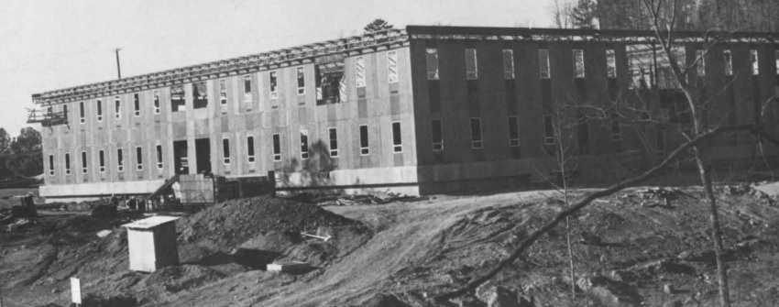

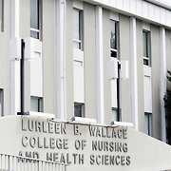

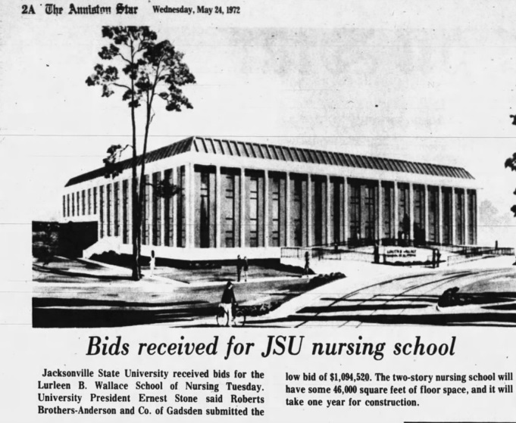

JSU Global Impact:

I think we discussed having a world map with points representing where JSU Nursing graduates are practicing or have practiced nursing. Here is some text that would be good and a list of locations.

*JSU Nursing’s vision statement is “Empowering exemplary nurses to care for anyone, anytime, anywhere”. JSU nursing graduates have worked diligently to improve the quality of healthcare in our local communities. Over the past 50 years, JSU has also made a global impact in the nursing profession with former graduates practicing nursing in Atlanta, Los Angles, New York, Washington, London, Tokyo, and Riyadh, Saudi Arabia.*

List of Locations for map:

Atlanta, Georgia

Washington, D.C.

Los Angeles, California

London, England

Tokyo, Japan

Riyadh, Saudi Arabia

Birmingham, Alabama

Gadsden, Alabama

Anniston, Alabama

Huntsville, Alabama

Montgomery, Alabama

Abuja, Nigeria

Denver, Colorado

Provo, Utah

Greenville, South Carolina

Orlando, Florida

Raleigh, North Carolina

Baltimore, Maryland

Philadelphia, Pennsylvania

San Diego, California

Palm Beach Gardens, Florida

Scottsboro, Alabama

Pell City, Alabama

Pensacola, Florida

Jacksonville, Alabama

Chattanooga, Tennessee

San Francisco, California

I would also like to include a small section on the site that is dedicated to our online programs. This will still give those visiting the site an opportunity to explore our programs. Here are the programs that we could highlight and create a link to the program. Here are the links to the programs. Would it be possible to use a picture on each of the pages (see links below) and make the picture the link when they click on it? Maybe add text to each of the pictures identifying which program it is associated with. I have also included some text that might go well with this section.

*Interested in advancing your nursing education?*

RN to BSN (STEP) program link: <http://www.jsu.edu/nursing/step.html>

MSN link: <http://www.jsu.edu/nursing/MSN/community.html>

Doctor of Nursing Practice link: <http://www.jsu.edu/nursing/DNP/index.html>